Aim:- Write a R program to take input from the user (name and age) and display the values.

Code:--

name<-readline(prompt = "enter the number")

x<-readline(prompt = "enter the age")

age<-as.numeric(x)

cat("The name is",name)

cat("The age is",age)

Output:--

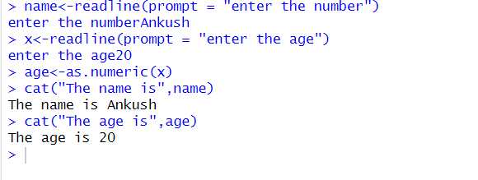

Aim:- Write R programming commands display the **getwd()**, **setwd()**, **ls()**.

Code:--

getwd()

# Replace "/path/to/your/directory" with the desired directory path

setwd("/path/to/your/directory")

# List the objects in the current workspace

ls()

Output:--

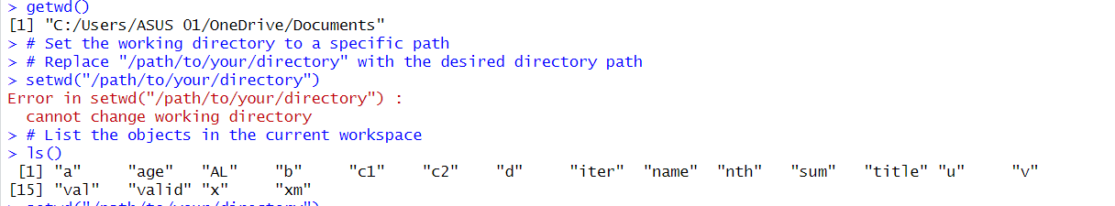

Aim:- Write a R program to create the system's idea of the current date with and without time.

Code:--

# Get current date and time

current_datetime <- Sys.time()

# Extract date without time

current_date <- as.Date(current_datetime)

# Display current date with and without time

cat("Current date with time:", current_datetime, "\n")

cat("Current date without time:", current_date, "\n")

Output:--

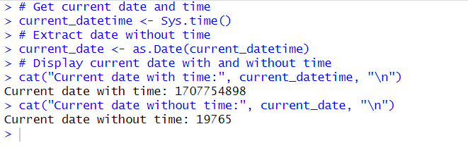

Aim:- Use R to calculate the following:

* 31 * 78
* 697 / 41

Code:--

a<-31*78

b<-697/41

print(a)

print(b)

Output:--

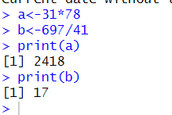

Aim:- Assign the value of 39 to x.

Code:--

x<-39

print(x)

Output:--

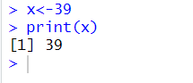

Aim:- Assign the value of 22 to y

Code:--

y<-22

print(y)

Output:--

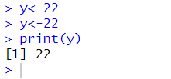

Aim:- Make z the value of x – y

Code:--

x<-39

y<-22

z<-x-y

print(z)

Output:--

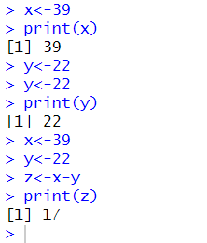

Aim:- Display the value of z in the console

Code:--

x<-39

y<-22

z<-x-y

print(z)

Output:--



Aim:- Type the following code, which assigns numbers to objects x and y.

* x <- 10
* y <- 20

1. Calculate the product of x and y.
2. Store the result in a new object called z.

Code:--

x<-10

y<-20

z<-x*y

print(z)

Output:--

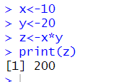

Aim:- Consider two vectors, x, y

* x=c(4,6,5,7,10,9,4,15)
* y=c(0,10,1,8,2,3,4,1)

What is the value of: x*y and x+y

Code:--

x=c(4,6,5,7,10,9,4,15)

y=c(0,10,1,8,2,3,4,1)

x*y

x+y

Output:--

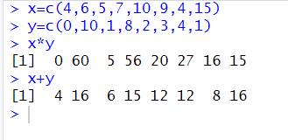

Aim:- Consider two vectors, a, b

* a=c(1,5,4,3,6)
* b=c(3,5,2,1,9)

What is the value of: a<=b

Code:--

a=c(1,5,4,3,6)

b=c(3,5,2,1,9)

a<=b

Output:--

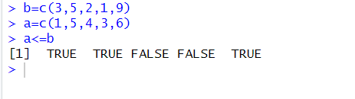

Aim:- If x=c(1:12)

What is the value of: dim(x)

What is the value of: length(x)

Code:--

x=c(1:12)

dim(x)

length(x)

Output:--

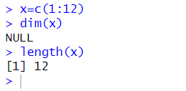

Aim:- Consider two vectors, x, y

* x=letters [1:10]
* y=letters[15:24]

What is the value of: x<y

Code:--

x=letters [1:10]

y=letters[15:24]

x<y

Output:--

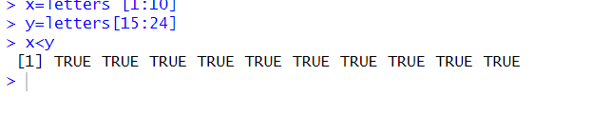

Aim:- Consider two vectors, a, b

* a=c(10,2,4,15)
* b=c(3,12,4,11)

What is the value of: rbind(a,b)

Code:--

a=c(10,2,4,15)

b=c(3,12,4,11)

rbind(a,b)

Output:--

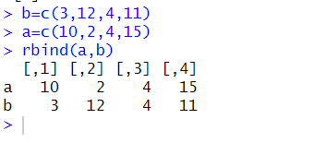

Aim:- Consider two vectors, a, b

* a=c(1,2,4,5,6)
* b=c(3,2,4,1,9)

What is the value of: cbind(a,b)

Code:--

a=c(1,2,4,5,6)

b=c(3,2,4,1,9)

cbind(a,b)

Output:--

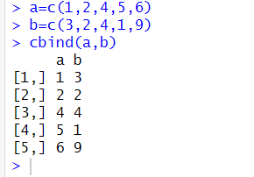

Aim:- Write a R program to find the factors of a given number.

Code:--

number<-24

factor<-c()

for(i in 1:number){

if(number%%i==0){

factor<-c(factor,i)

}

}

factor

Output:--

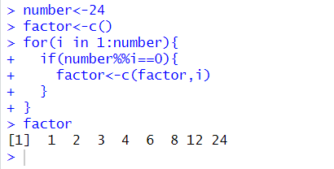

Aim:- Write a R program to find the maximum and the minimum value of a given vector

Code:--

a=c(1,200,42,57,64)

max(a)

min(a)

Output:--

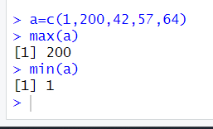

Aim:- Write a R program to create three vectors numeric data, character data and logical data. Display the content of the vectors and their type.

Code:--

a=c(1,200,42,57,64)

b<-c("abas","avs","jays")

c<-c(TRUE,FALSE)

typeof(a)

typeof(b)

typeof(c)

Output:--

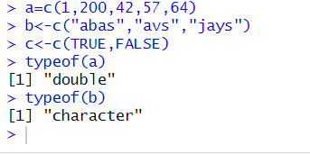

Aim:- Create a vector and find how many numbers are there in the vector x?

Code:--

a=c(1,200,42,57,64)

length(a)

Output:--

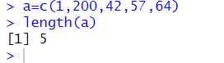

Aim:- Create two vectors x and y and find how many numbers will x + y generates?

Code:--

x <- c(1, 2, 3)

y <- c(4, 5, 6, 7)

result_length <- max(length(x), length(y))

cat("Number of numbers generated when adding x and y:", result_length)

Output:--

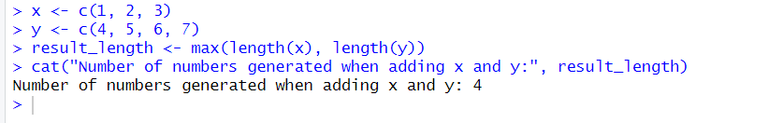

Aim:- Create a vector and find what is the sum of all values in x?

Code:--

x <- c(1, 2, 3)

S<-sum(x)

S

Output:--

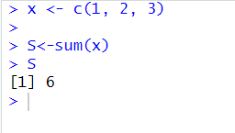

Aim:- Create a vector and find what is the sum of y times y?

Code:--

y<-c(4,5,7,8)

s<-sum(y*y)

s

Output:--

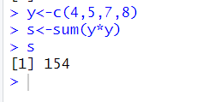

Aim:- Create two vectors x and y and find what do you get if you add x and y?

Code:--

y<-c(4,5,7,8)

x<-c(9,4,3,7)

result<-y+x

result

Output:--

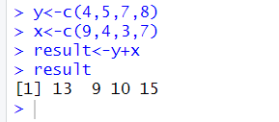

Aim:- Create a vector x and assign x times 2 to a new vector named z

Code:--

x<-c(9,4,3,7)

z<-2*x

z

Output:--

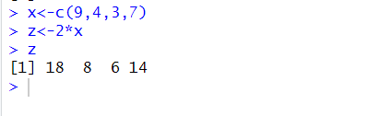

Aim:- How many numbers will z have, why?

Code:--

x<-c(9,4,3,7)

z<-2*x

z

length(z)

# z will be equal to the length of the longer input vector

Output:--

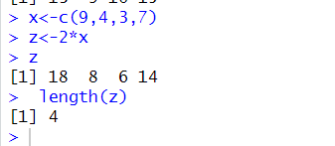

Aim:- Assign the mean of z to a new vector named z.mean and determine the length of z.mean

Code:--

x<-c(9,4,3,7)

z<-2*x

z

z.mean<-c(mean(z))

z.mean

Output:--

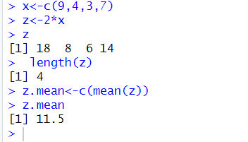

Aim:- Create a numeric vector with all integers from 5 to 107

Code:--

x<-c(5:107)

x

Output:--

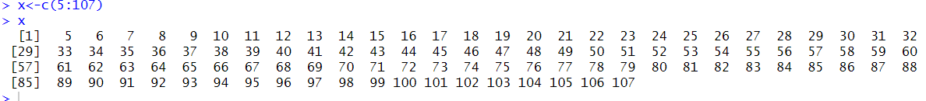

Aim:- Create a numeric vector with the same length as the previous one, but only containing the number 3

Code:--

x<-c(5:107)

new_vector <- rep(3, length(x))

new_vector

Output:--



Aim:- Create a vector that contain all numbers from 1 to 17, where each number occurs the same number of times as the number itself eg. 1, 2, 2, 3, 3, 3…

Code:--

x<-c(1:17)

result<-c()

for(i in x){

result<-c(result,rep(i,i))

}

result

Output:--

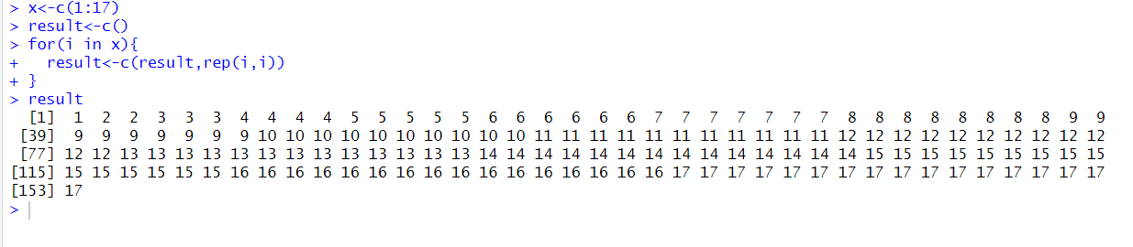

Aim:-Sort the vector x <- c(1, 3, 2, 5, 4) in:

* ascending order
* descending order

Code:--

x <- c(1, 3, 2, 5, 4)

asc<-sort(x)

des<-sort(x,decreasing = TRUE)

asc

des

Output:--

